**DAILY ONLINE ACTIVITIES SUMMARY**

|  |  |  |  |  |  |  |  |  |
| --- | --- | --- | --- | --- | --- | --- | --- | --- |
| **Date:** | **17-06-2020** | | | | | **Name:** | **Deeksha D Poojary** | |
| **Sem & Sec** | **VIII Semester & A Section** | | | | | **USN:** | **4AL16CS026** | |
| **Online Test Summary** | | | | | | | | |
| **Subject** | | **-** | | | | | | |
| **Max. Marks** | | **-** | | **Score** | | | **-** | |
| **Certification Course Summary** | | | | | | | | |
| **Course** | **Introduction to Amazon Elastic Compute Cloud (EC2)** | | | | | | | |
| **Certificate Provider** | | | **Amazon Web Service** | | **Duration** | | | **10 minutes** |
| **Coding Challenges** | | | | | | | | |
| **Problem Statement: Write a program for smallest positive integer values.** | | | | | | | | |
| **Status: COMPLETED** | | | | | | | | |
| **Uploaded the report in Github** | | | | | **YES** | | | |
| **If yes Repository name** | | | | | **deekshapoojari** | | | |
| **Uploaded the report in slack** | | | | | **YES** | | | |

Online Test Details:

NIL

Certification Course 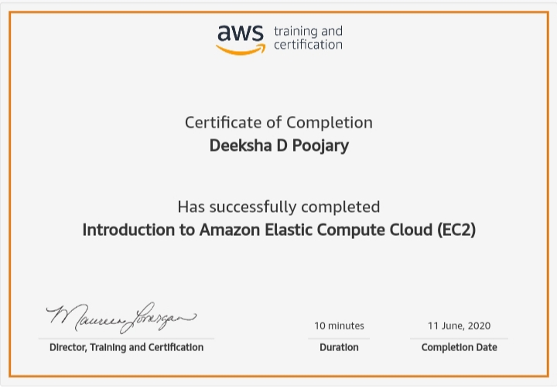Coding Challenges Details:

|  |
| --- |
|  |
|  |
|  |
|  |
|  |
|  |
|  |
|  |
|  |
|  |
|  |
|  |
|  |
|  |
|  |
|  |
|  |
|  |
|  |
|  |
|  |
|  |
|  |
|  |
|  |
|  |
|  |
|  |
|  |
|  |
|  |
|  |
|  |
|  |
|  |
|  |
|  |
|  |
|  |
|  |
|  |
|  |
|  |
|  |
|  |
|  |
|  |
|  |
|  |
|  |
|  |
|  |
|  |
|  |

**Program1:**

|  |  |  |  |
| --- | --- | --- | --- |
|  | | |  |
| **#include<stdio.h>** |
|  | **void main()** | |
|  | **{** | |
|  | **int a[15], val = 1, i, n;** | |
|  | **printf("Enter the value of N: ");** | |
|  | **scanf("%d", &n);** | |
|  | **printf("Enter the numbers:\n");** | |
|  | **for(i = 0; i < n; i++)** | |
|  | **scanf("%d", &a[i]);** | |
|  | **for (int i = 0; i < n && a[i] <= val; i++)** | |
|  | **val = val + a[i];** | |
|  | **printf("\n%d\n", val);** | |
|  | **}** | |